Assignment-18.1:

a.) Run a map only job on the word count program using static configurations.

b.) Run the mapreduce word count program and set the number of reducers to 2 using static configurations.

Run a map only job on the word count program using static configurations.

Driver Class:

We are setting the Num reduce tasks to zero since it is a map only job and we are setting the Output format class to sequence file output format

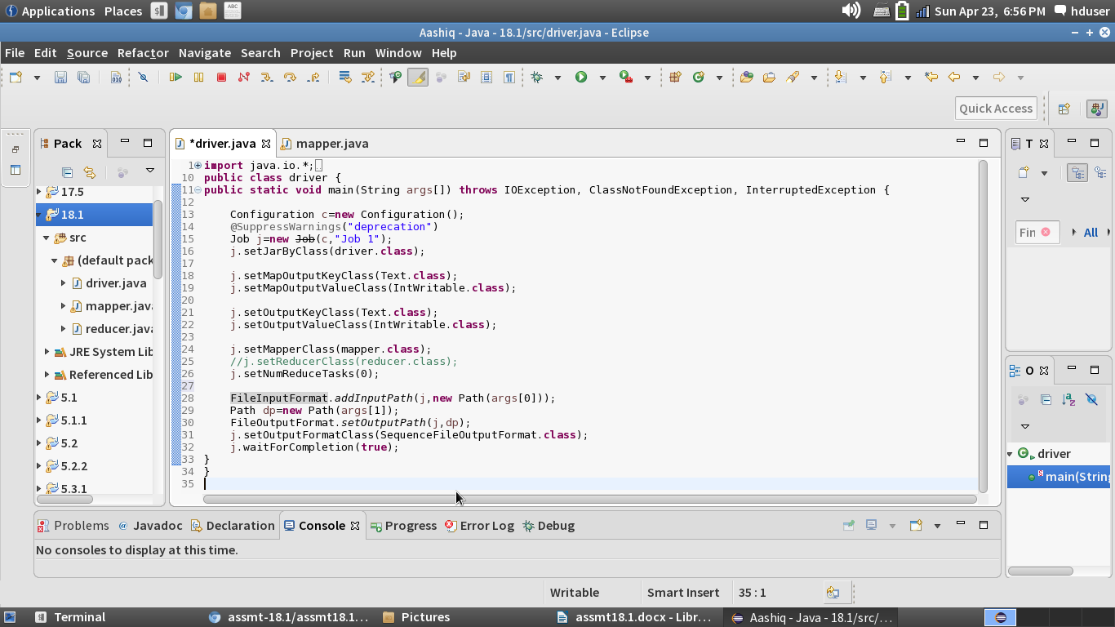

Mapper Class:

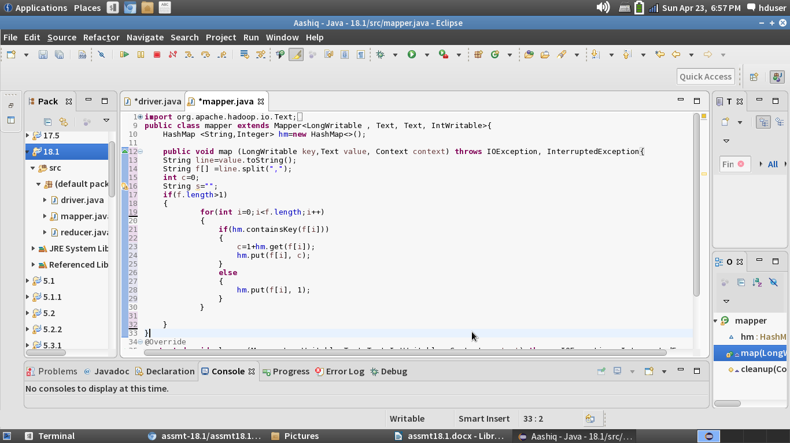

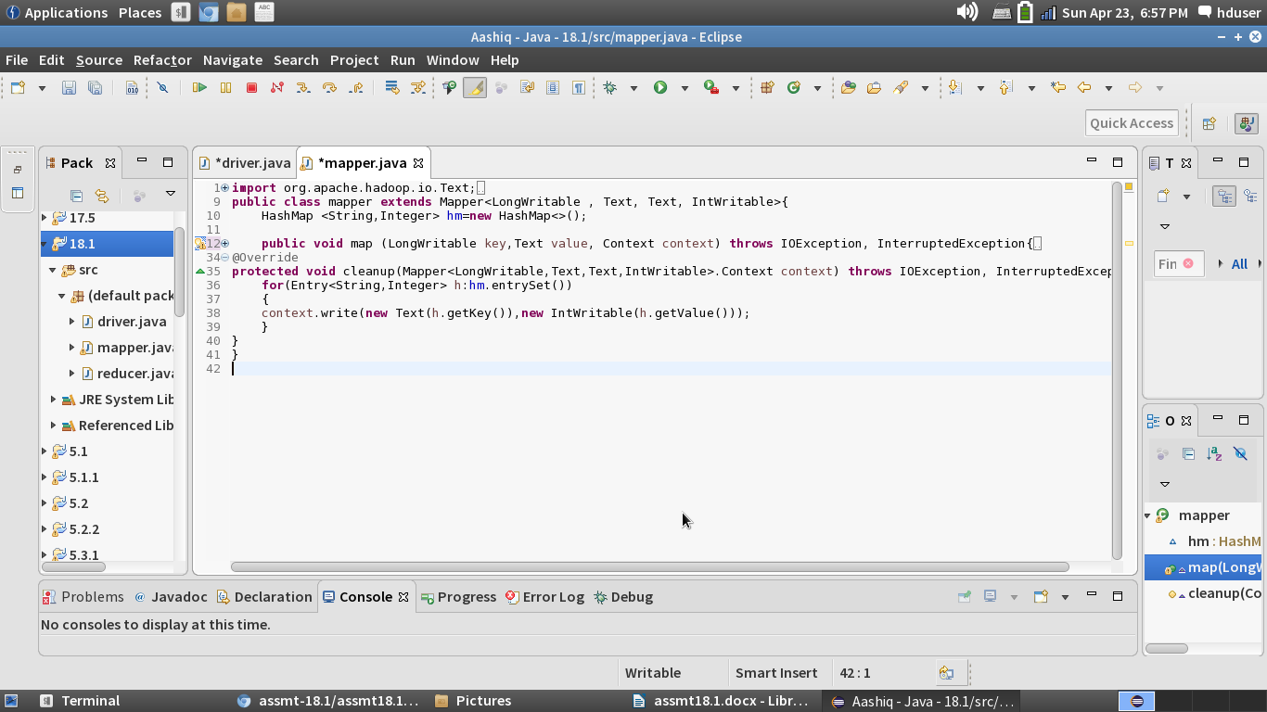

In the mapper class we are using a Hashmap and updating it in such a way that if the word repeats we will increase the count by 1 and put it in hash map or else give a value of 1.

Running the jar File:

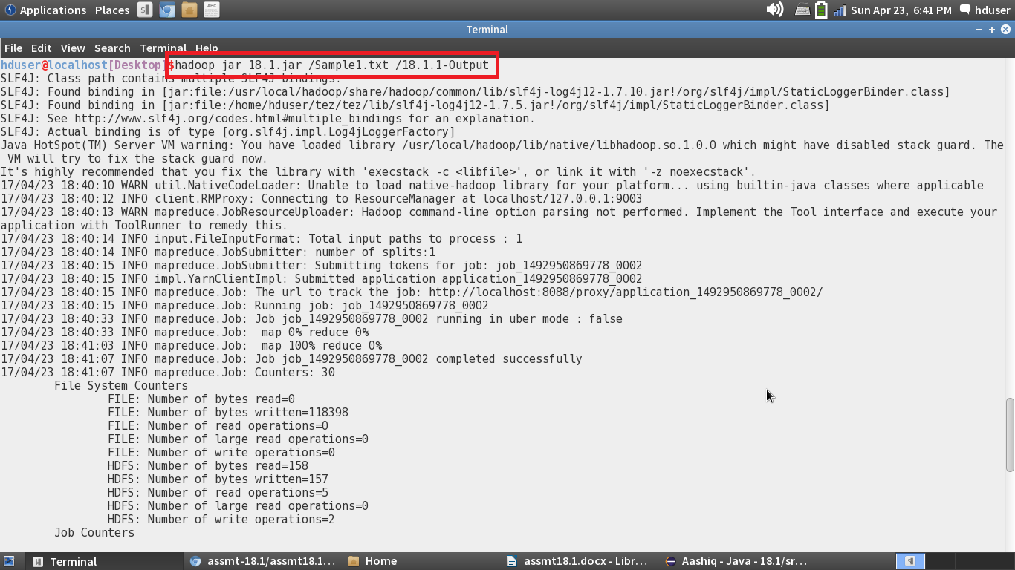

Output:

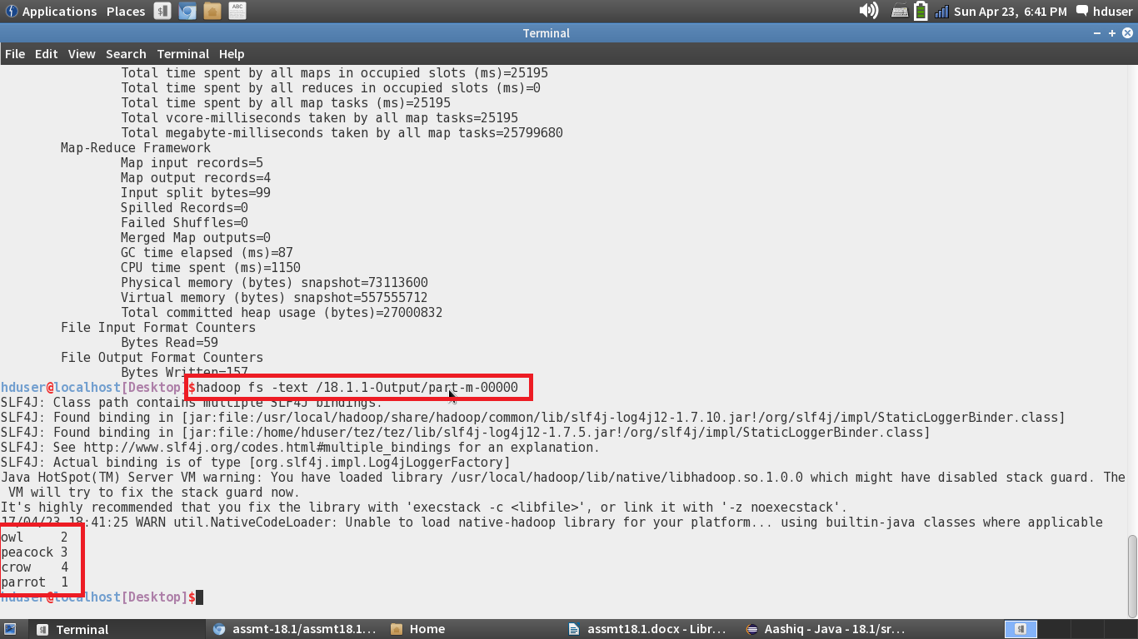

Run the mapreduce word count program and set the number of reducers to 2 using static configurations

Driver Class:

We are setting the map reduce tasks to 2 in the driver class

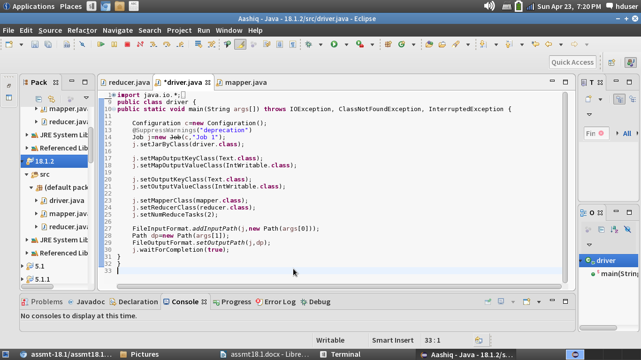

Mapper Class:

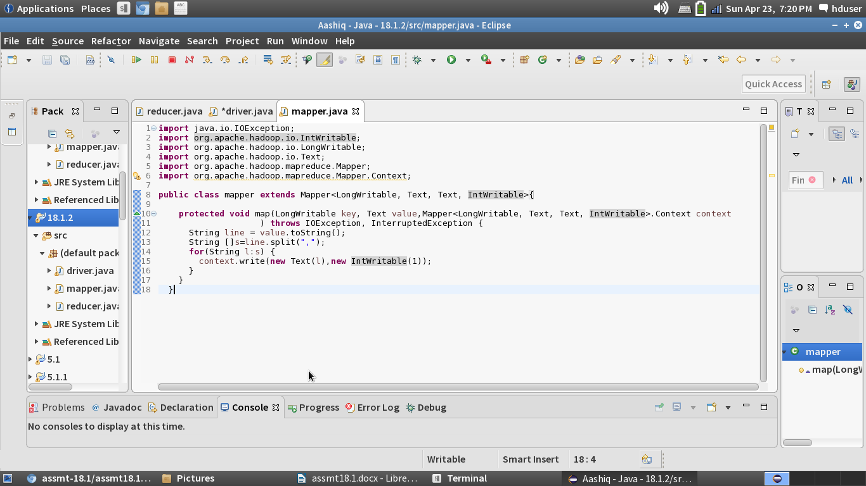

Reducer Class:

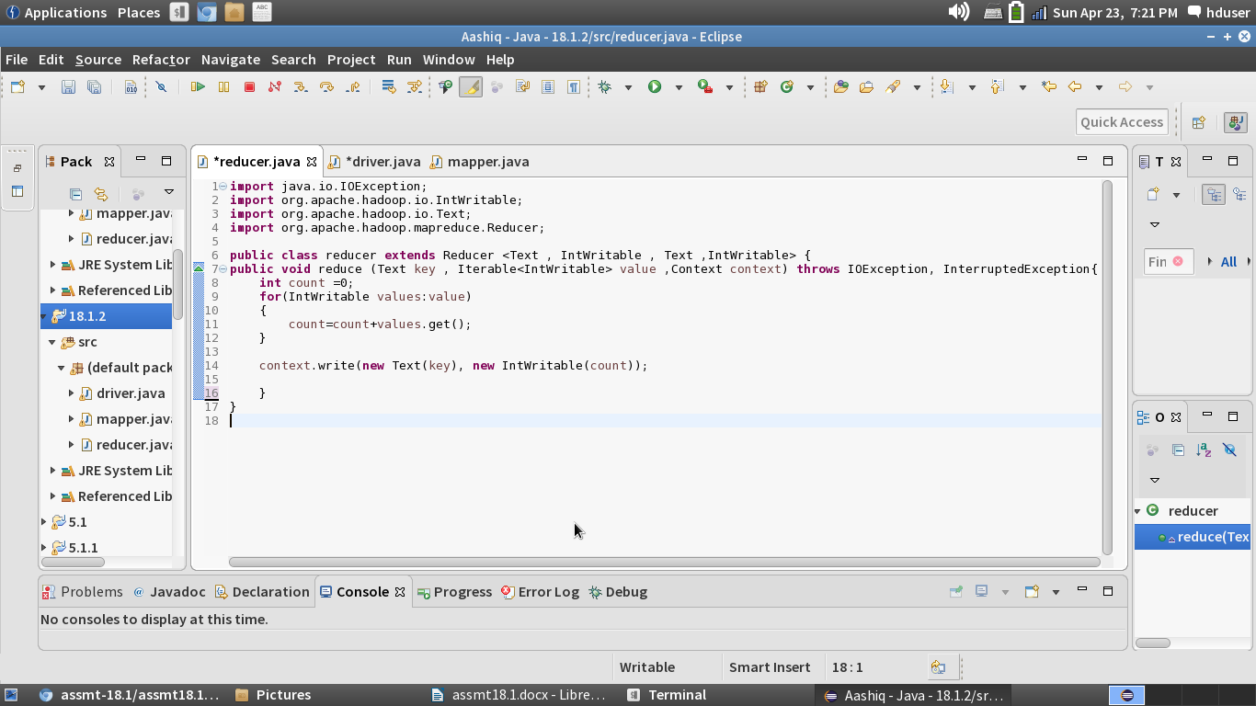

Running the Jar File:

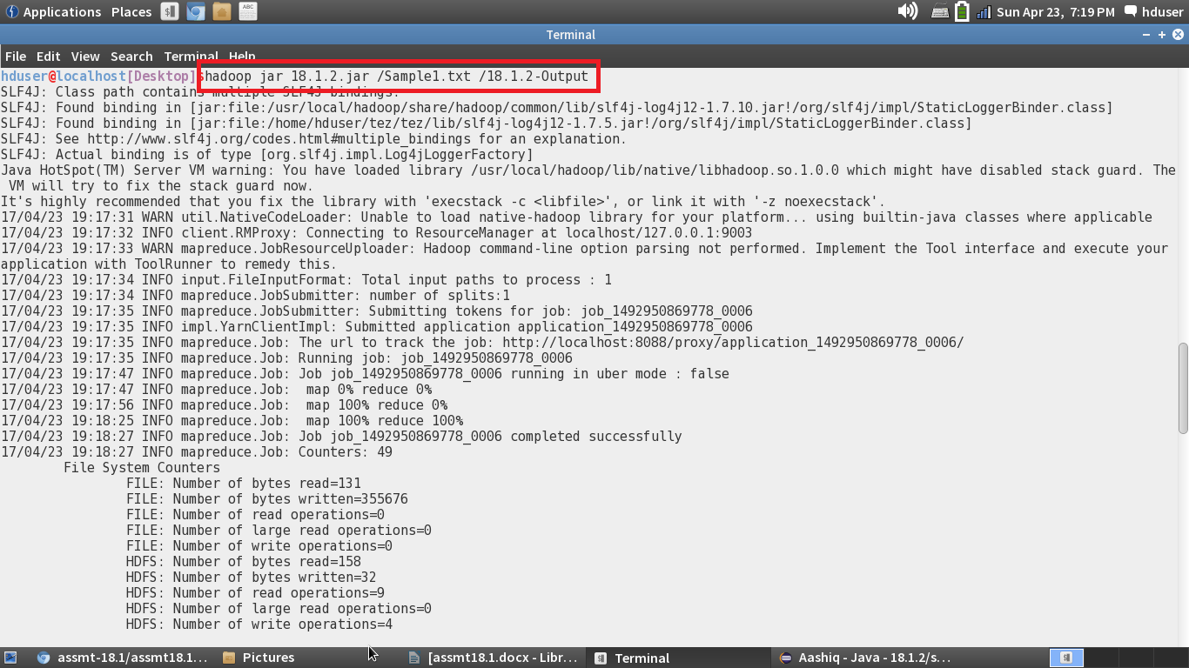

Output:

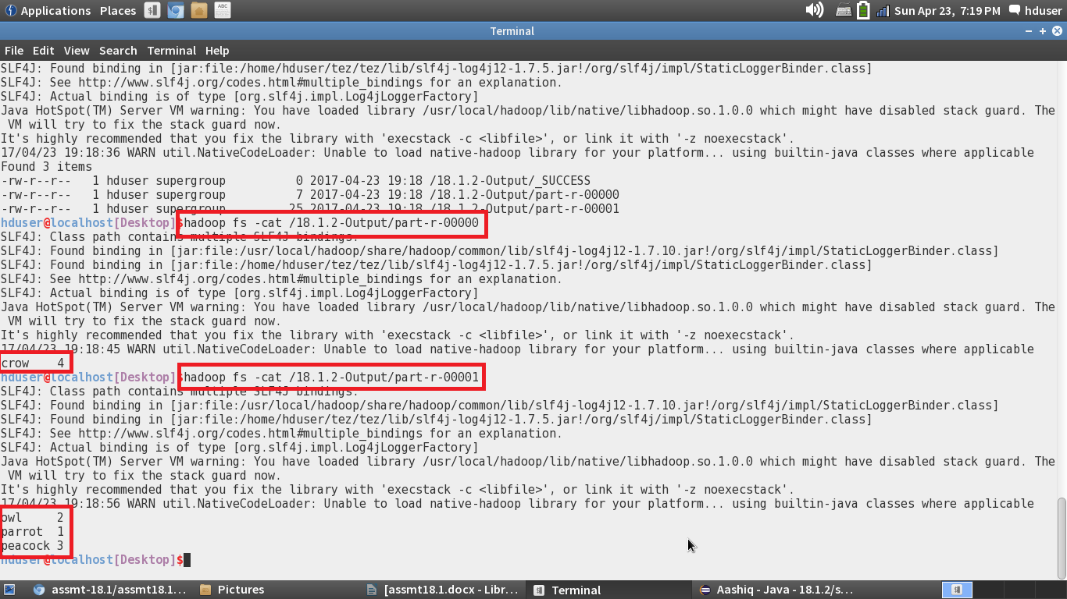

Here we can see that the output was stored in 2 reducers